Laiba Fatima 22k-5195

SDA LAB 2

Task 1:

1. Identify the actors for the following system.

Librarian, Library Member

1. What are the use cases you can find?

Library Member:

1. Search books (by title, author, subject category, publication date)
2. Reserve books
3. Checkout

Librarian:

1. Add books
2. Delete books
3. Retrieve information (of members and books)
4. Collect fines
5. Design the Complete USE CASE diagram for given System.

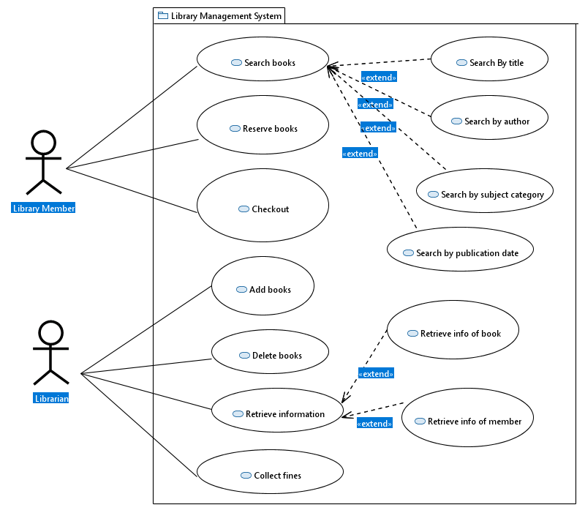

Task 2:

1. Identify the actors for the following system.

User (buyer / seller)

1. What are the use cases you can find?
2. Add new products for selling
3. Search Products (by name or category)
4. View products

Only for registered user:

1. Buy products
2. Add product items in cart
3. Remove product items from cart
4. modify product items in cart
5. Checkout items
6. Rate product
7. Review product
8. Specify shipping address
9. Cancel order
10. Get notifications
11. Pay (through credit card or bank transfer)
12. Track shipment
13. Design the Complete USE CASE diagram for given System.

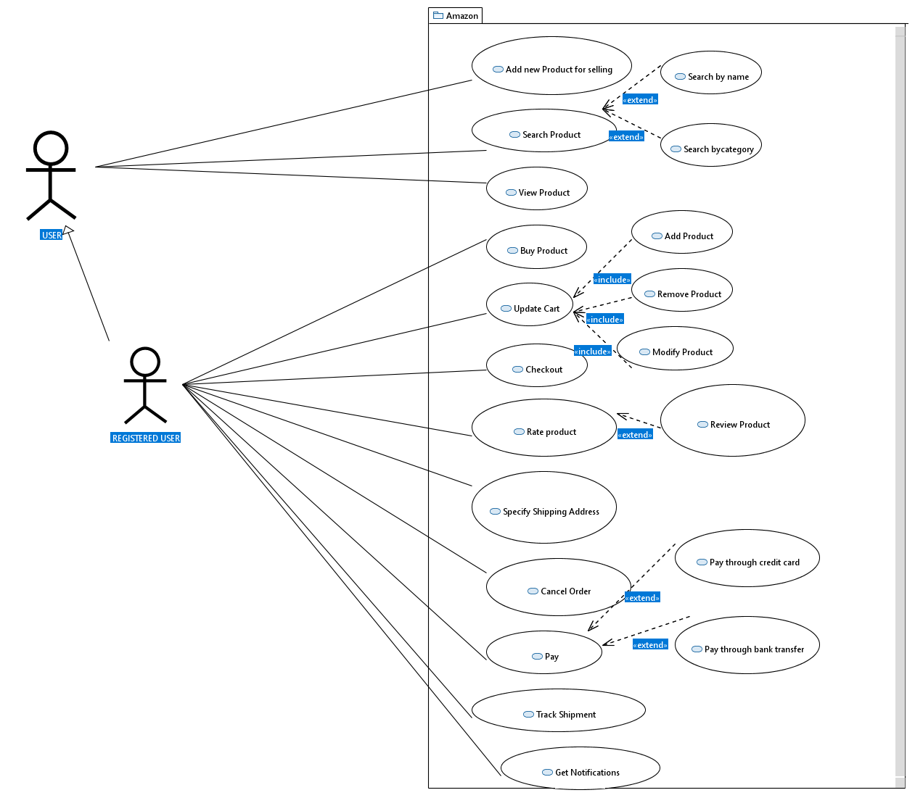

Task 3:

1. Identify the actors for the following system.

Members

1. What are the use cases you can find?
2. Add information (about basic profile, experiences, education, skills, and accomplishments)
3. Search (members and companies)
4. Connect (send and accept requests)
5. Request recommendation
6. Create new posts
7. Add comments, likes, share
8. Sends messages
9. Create company page
10. Add job postings
11. Create groups
12. Join Groups
13. Follow (members and companies)
14. Design the Complete USE CASE diagram for given System.

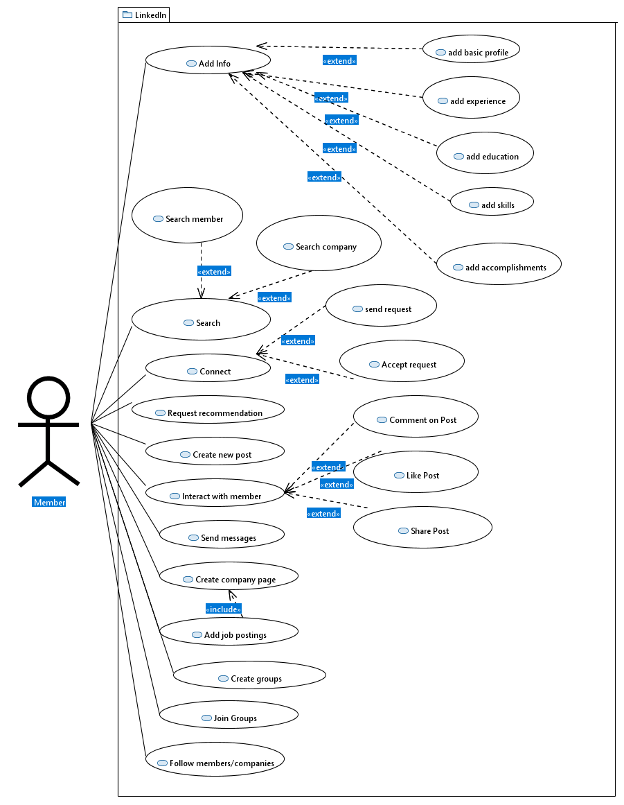

Task 4:

1. Identify the actors for the following system.

Customers, Admin

1. What are the use cases you can find?

Customer:

1. Search flight
2. Search source/destination airport
3. Reserve ticket
4. Build multi-flight itinerary
5. Check details (flight schedule, departure time, available seats, arrival time)
6. Make reservation for multiple passengers
7. Get notifications
8. Cancel reservation and itinerary.

Admin:

1. Add new aircraft, flight, flight schedule
2. Cancel pre-scheduled flights (notification will be sent to all stakeholders).
3. Design the Complete USE CASE diagram for given System.

